Special Information Types (SIT) in Oracle Applications

By: [Guest Author](https://blogs.oracle.com/author/guest-contributor)

In this blog I will explain how to create SIT in Oracle HRMS Person screen.SIT is basically a **KFF**.This we can use to capture additional person information.The KFF which we are using here is **Personal Analysis Keyflexfield**.We can create and assign N number of SITs to a person.Once you enable the SIT it is available across the Application.

Following steps needs to be done to create a SIT.

1) Define a structure for the **Personal Analysis Keyflexfield**. For this you have to navigate to   
  
**Application Developer** > **Flexfield**> **Key**> **Segments**  
  
Query for **Personal Analysis Flexfield**.

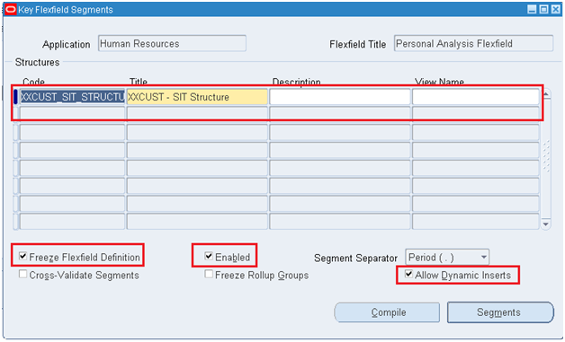

2) Define the segments.

Click on **Segments**.Create the Segments based on your requirement.

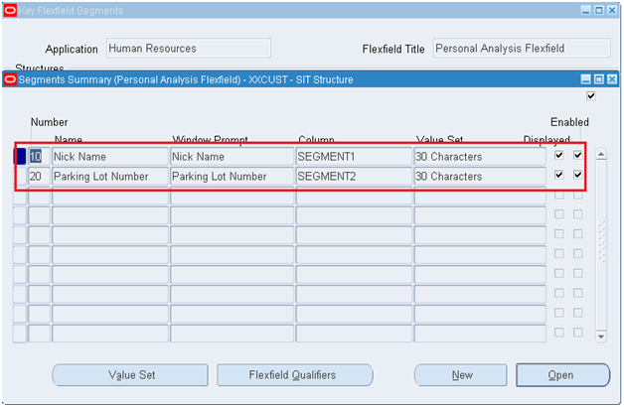

In the Segments window check **Allow Dynamic Inserts** check box. Once you complete the segment definition check **Freeze Flexfield Definition** and save your work.

3) Enable the SIT.

For this navigate to  
  
**US Super HRMS Manager** > **Other Definitions** > **Special Information Types**  
  
Create a record for above created structure.Check the check box matrix where ever you want to show the SIT.In this example I am enabling it for Person.

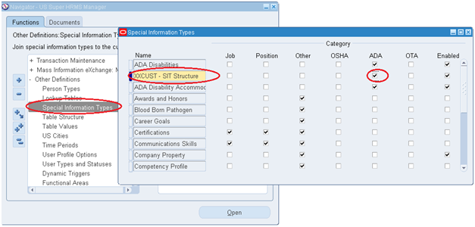

Save your work.

4) Go to any HRMS responsibility.Open **Enter and Maintain** form.Click on **Special Information**.Query for above created structure.Enter the information into the segments.

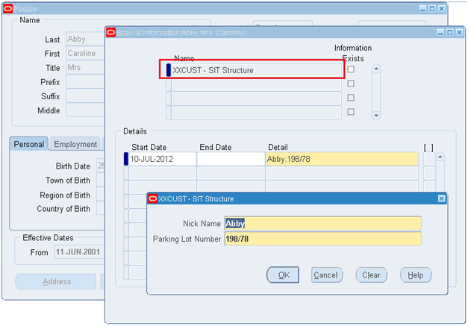

The entry will get created in **PER_PERSON_ANALYSES** and **PER_ANALYSIS_CRITERIA**table.

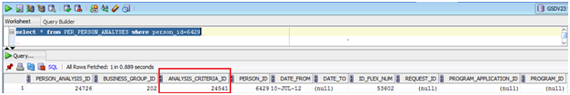

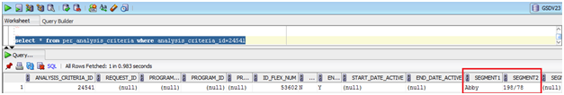

The API to create SIT information is **HR_SIT_API**.